0827290 Gydo Geijer

11-12-2017

**Habitat suitability of *Ensete ventricosum* under present and futureclimatic conditions**

**Introduction**

*Ensete ventricosum* Cheesmanis a flowering monocot in the order Zingiberales, family Musaceae, and is more commonly known as the Enset or false banana. It is native to a large part of Eastern Africa, ranging from South-Africa to Ethiopia, and is characterized by a large herbaceous growth with leaves similar to the bananas from the genus *Musa. Ensete ventricosum* bears bananas as fruits, but contrary to *Musa,* these bananas are considered inedible due to them lacking any sort of taste. However, the edible roots make *E. ventricosum* the most important food crop in several African countries, since it is able to tolerate sparse precipitation better than most cereal crops.

Since *E. ventricosum* is a main food source in a number of countries, and more extreme climatic conditions are thought to increase due to climate change, this study aims to investigate the habitat suitability of *E. ventricosum* under current and future climatic conditions.

**Methods**

Georeferenced species occurrence data was downloaded from GBIF. All data point were used. Climate variables were downloaded from worldclim.org, with a resolution of 5 arc minutes. Bioclimatic conditions were chosen for the present (1960-1990, bio 5m variables) and for the future (2050, rcp45 column, bi variables). A selection of the variables was made using a spearman rho > 0.7 to test for correlation. This resulted in the seven variables considered most important (Table 1). Temperature based variables were considered important since *E. ventricosum* is a tropical plant species, which is adapted to high temperatures and is not cold resistant. *E. ventricosum* is also considerably drought resistant, which makes an increase or further decrease in precipitation an important variable.

**Table 1.**

|  |  |
| --- | --- |
| **Temperature** | **Moisture** |
| Bio2 Mean diurnal range | Bio18 Precipitation of warmest quarter |
| Bio5 Max temperature of warmest month | Bio19 Precipitation of coldest quarter |
| Bio7 Temperature annual range |  |
| Bio8 mean temperature of wettest quarter |  |
| Bio9 mean temperature of driest quarter |  |

The model was designed with Maxent. Global occurrence of *E. ventricosum* was imported into Maxent in the samples section. ClimateTraining data created with R was imported as environmental layer and the present and future climate data was imported as projection layers, as seen in figure 1.

Linear, quadratic, product and hinge features were used in the model. This ensured the output distribution is constrained to the same covariance of all pairs of samples and environmental variables.

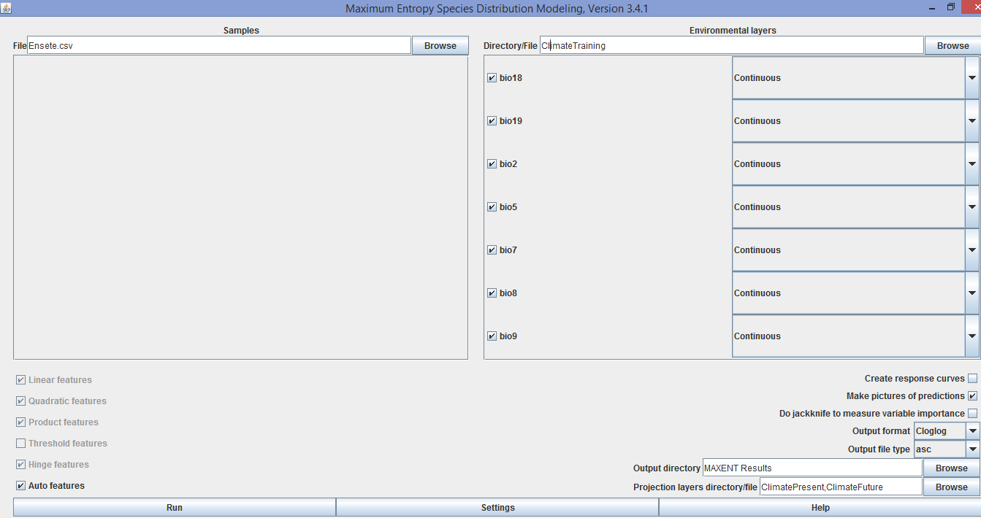

**Figure 1.** Setting as used by Maxent.

**Model output**

Figure 2 and 3 below show the output from the Maxent model. Some differences in habitat suitability are apparent, especially in Europe.

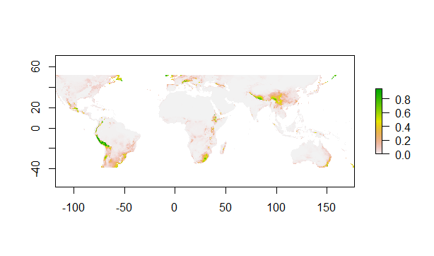

**Figure 2.** Present habitat suitability for *E. ventricosum*.

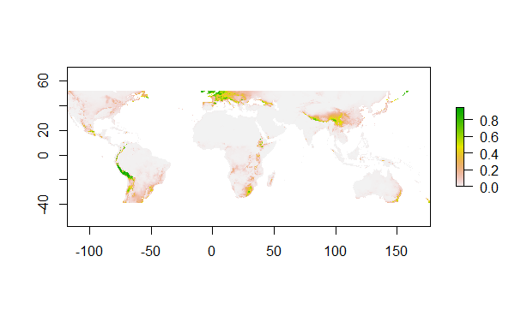

**Figure 3**. Future habitat suitability for*E. ventricosum*.

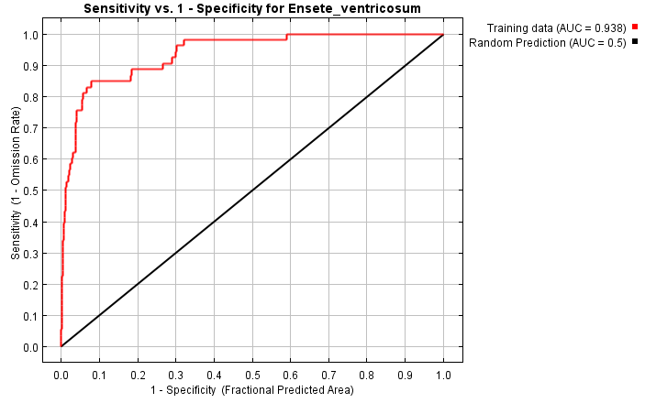

**Figure 4.** Graph depicting theArea under Curve (AUC).

The Area Under Curve of the Receiver Operator Curve (ROC) is 0.938, indicating that this is a good model based on AUC alone, since the score > 0.8. The Maximum training sensitivity plus specificity threshold is 0.287. Figure 5 shows that several Bioclim variables are important contributors to the model, with Bio7 (Temperature annual range) being the most influent in this model.

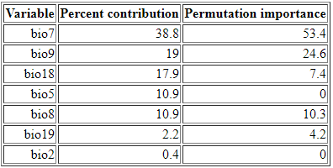

**Figure 5.** Percentages of contribution to the model of different Bioclim variables.

**Response to future scenario**

This model output shows the distribution of *E. ventricosum* to remain similar to present conditions in most areas. A decrease in habitat suitability is expected for Europe.

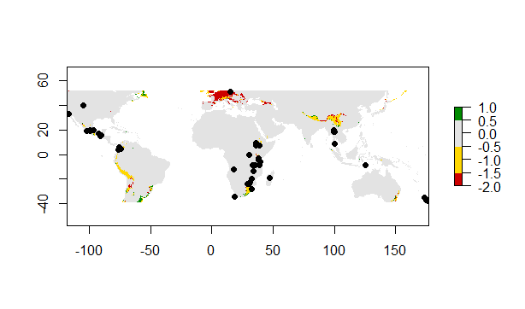

**Figure 6.** Predicted distribution under future conditions for *E. ventricosum.*

**Biological interpretation**

Figure 2 and 3 show increasing habitat suitability for Europe as the most apparent change in habitat suitability for *E. ventricosum*. However, figure 6 depicts a predicted decrease in future distribution in Europe. This might be because the data downloaded from GBIF contained several occurrences in Europe, where *E. ventricosum* does not occur under natural circumstanced, only in botanical or domestic gardens. With such a low number of georeferenced occurrences (107), this might influence the model. Also, 2050 is not that far into the future, which would make it improbable for a typical tropical plant species to shift its habitat to a largely temperate zone as Europe. With increasing global temperature, the temperature and climate of Europe might become more suitable for *E. ventricosum,* but this model cannot predict with any certainty if and when this might occur.

The reliability of this model is to be questioned, since it was only run once, and indicating model accuracy with AUC values only has major drawbacks.

The validity of some of the data point may also be questioned, and since there are so few data points, this might be of influence to the model. Also, many data points place *E. ventricosum* in areas they would not be able to thrive naturally. To conclude, even though this model has a high AUC of 0.938, this model can only be considered useful, and cannot be seen as reliable for the prediction of future habitat suitability for *E. ventricosum.*